The Physics of Sprinting
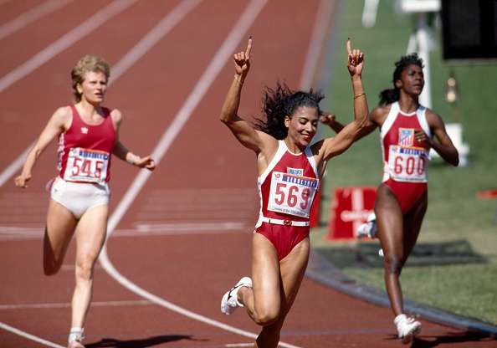

The school record for the 100m sprint at school in year 8 is 11.53 seconds
What would the average speed for this pupil have been during the race?

Would this have been his maximum speed? What do you think his maximum speed might have been?

At what point in the race do you think he was travelling at his maximum speed.

Draw what you think would be a suitable displacement/ time graph for this pupil during the race.

Draw what you think would be a suitable Velocity/ Time graphs for this race.

Vertigo analysis

What was X’s maximum speed?

At what time did this occur?

Do you think Usain Bolt would have a similar shape graph to X’s?

What was X’s average speed? How can you work this out?

Do these graphs resemble the ones you drew earlier? If there are differences, what are they?

Do you think you would be able to use this data to help improve X’s performance in the 100m sprint?

If so, how?

